OBJECTIVES:
- To examine the I/O port operation using a simulator.
- To trace through a CALL subroutine using a simulator.

MATERIAL:
- Atmel Studio
- https://lcgamboa.github.io/js/picsimlab.html?../picsimlab_examples/ (Simulator)

WEB SITES:
- www.microchip.com for Atmel Studio Software

ACTIVITY 1
Test the operation of an “up-counter” from $00 - $FF on picsimlab. Connect the LEDs to each pin of the PORTD and perform the following steps:
- Assemble the following code:
;========Press your up-counter code here==========
RESET:
;Configure PORTD as Output
LDI R16, 0xFF
OUT DDRD, R16

;Initialize Counter Register
LDI R16, 0x00

MAIN_LOOP:
; Output
OUT PORTD, R16

; Call Delay
CALL DELAY

; Increment Counter
INC R16

; Loop back

RJMP MAIN_LOOP

;=================================================
DELAY: LDI R21, 32
DL1: LDI R22, 200
DL2: LDI R23, 250
DL3: NOP
NOP
DEC R23
BRNE DL3
DEC R22
BRNE DL2
DEC R21
BRNE DL1
RET
- Upload the hex file to the picsimlab.
- Observe the LEDs counting up from $00 to $FF.
- Change the time delay in between the counts by changing the value of R21 register (or increase/decrease the number of NOPs) but make sure the time delay is long enough that you can observe the LEDs counting up. Create a hex file then upload to picsimlab to see what differences.
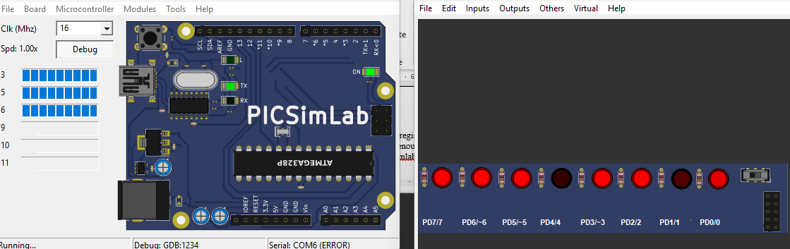
the LEDs on PORTD display a binary count where the lights appear to move to the left as the value increases from $00 toward $FF. Once the counter reaches the maximum 8-bit value of 255, it automatically rolls over and loops back to 0 to start again. By adjusting the R21 register in the delay subroutine, the time between counts changes, causing the LEDs to flicker and increment either faster or slower.

ACTIVITY 2
In Activity 1, the maximum count was $FF (or 255). Modify the above program to set maximum count to 10.
- Upload the hex file into the AVR simulator.
- Observe the LEDs counting up from $00 to $09 (00001001 binary) continuously.
- Change the maximum count to the value of your age and observe the LED counting up to that number.
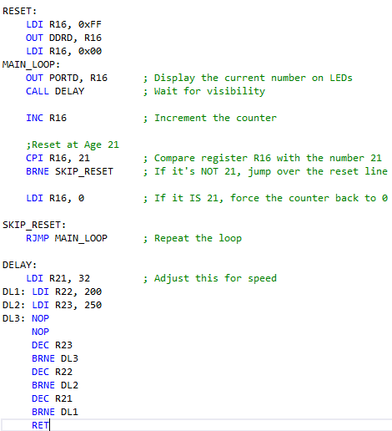
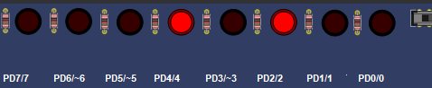
the LEDs on PORTD display a binary count from 1 to 20. When the counter reaches your age of 21 ($00010101_2$), the LEDs at D4 (PD4), D6 (PD2), and D8 (PD0) light up briefly before the comparison logic triggers a reset to 0. Because the count is limited to 21, the "left" LEDs from D1 to D3 (PD7–PD5) remain off as the sequence never reaches those higher binary values.

ACTIVITY 3
For this activity, connect the DIP switches to pins of port B. Now, use the DIP switches on picsimlab to set the maximum count for an up-counter instead of using constant as Activity 1 and 2.
- Upload the hex file into the AVR simulator.
- Observe the LEDs counting up from 00 to the value set by the 8 switches continuously.
Answer question
- What is the maximum count for register R20?
- In this Lab, which port was used to display the count? Which one was used to set the maximum count? Can we use one port for both (inputting the maximum count and displaying the count)?
- In this Lab, we used BRNE (Branch Not Equal) instruction. Explain how it works.
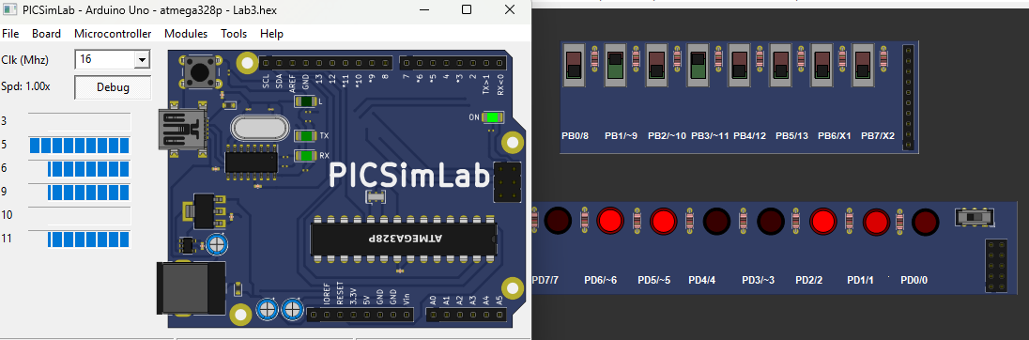
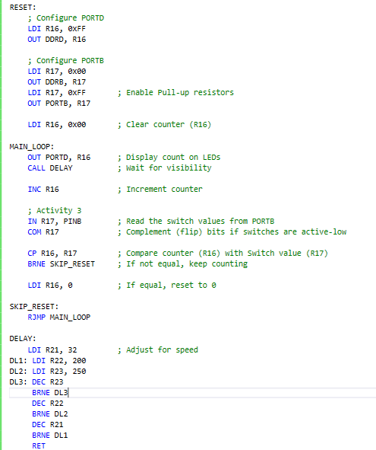
the LEDs on PORTD display a dynamic binary count determined by the limit set on the PORTB switches. By reading the state of the switches with the IN and COM instructions, the program compares the current count in R16 with the user-defined limit in R17. This allows the counter to reset to zero at any chosen value, providing a visual representation of how software logic interacts with physical input to control program flow.

